File Compression Tool For CLI
- Daniel Cujba -

The application has been designed to allow user to compress file and folder using different compression strategy such as Zip, Tar and TarGz, all from the command line interface.

The following design pattern has been used:

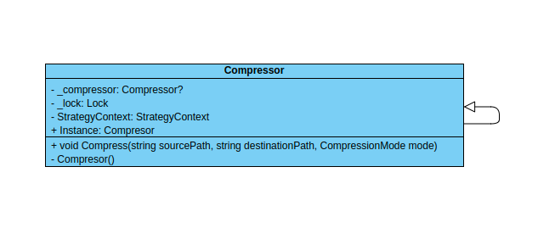
- Singleton: used by the Compressor class to instantiate the object just one and to be able to use it throughout the application

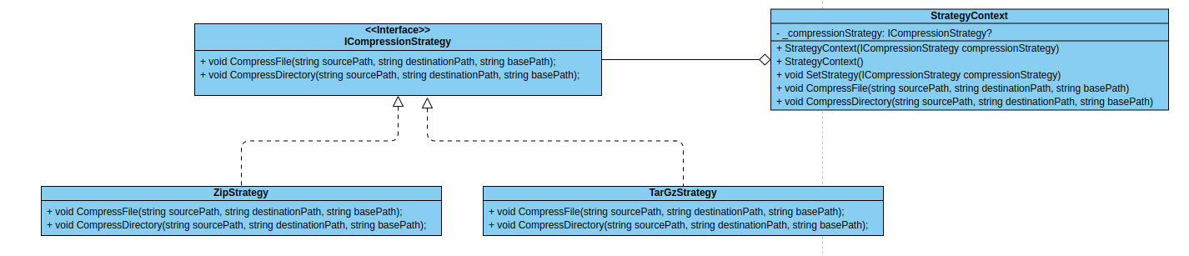
- Strategy: The user is able to choose between 2 compression archivers, Zip and Tar, both ZipStrategy and TarGzStrategy implement ICompressionStrategy and thorugh the use of StrategyContext the user manages which on to use

- Composite: used to cover every file and folder, in a folder tree structure, and to call the StrategyContext.Compress for each
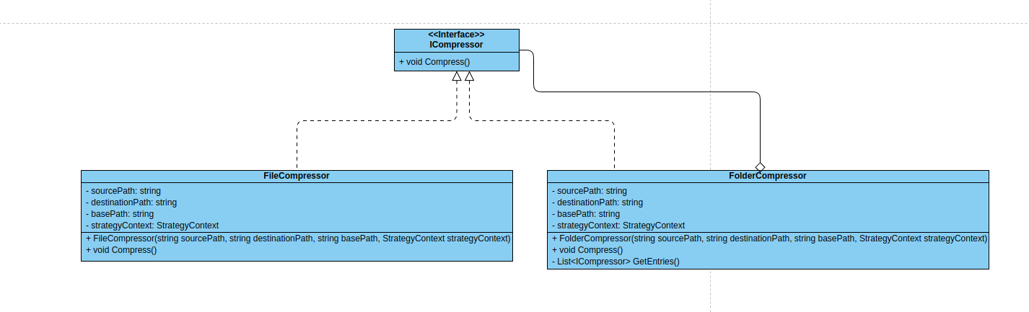

- Proxy: because TarGz compression has 2 steps, archivation (Tar) and compression (Gzip), we use a proxy to first archive the folder structure using the StrategyContext and FolderCompresor, after which we do a Gzip compression on the resulting file

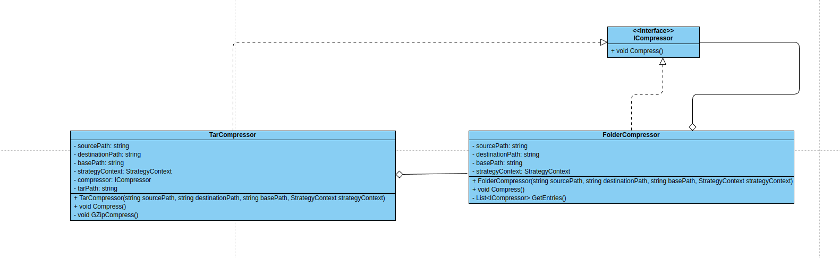

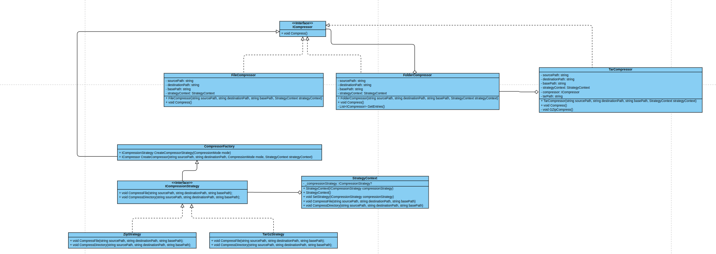
- Factory: it helps create the compression strategy base on the input of the user and the starting ICompressor base on the type of the source file/folder through CompresorFactory

